

Faculty of Engineering & Technology
Department of Computer Science
Artificial Intelligence (COMP338)

AI-Based University Course Scheduling Using Genetic Algorithm

Prepper by: Hutheyfa Abuznaid
Student Num: 1221065
Contents
Introduction 4
Problem Formulation 5
2.1 Hard Constraints 5
2.2 Soft Constraints 5
2.3 Fitness Function Evaluation 6
3. Genetic Algorithm 7
3.1 Chromosome & Gene Representation 7
3.2 Genetic Operators 7
1. Selection Mechanism 7
2. Crossover (Recombination) 7
3. Mutation Operator 7
4. Code Explanation 8
4.1 System Entities & Data Representation 8
4.2 Selection Methods 11
4.3 Crossover Operators 11
4.4 Mutation Operators 11
4.5 System Execution (CourseSchedulingSystem & runGA) 14
5. Experimental Work 15
5.1 Dataset 15
5.2 Experiment 1 – Population Size 16
5.3 Experiment 2 – Mutation Rate 17
5.4 Experiment 3 – Crossover Rate 18
5.5 Experiment 4 – Dataset Size 19
5.6 Advanced Requirement A – Selection Method Comparison 20
5.7 Advanced Requirement B – Crossover Method Comparison 22
5.8 Advanced Requirement C – Mutation Strategy Comparison 23
5.9 Advanced Requirement D – Genetic Algorithm vs. Hill Climbing 24
6. Results 26
6.1 Fitness Convergence 26
6.2 Final Timetable 27
6.3 Constraint Violation Audit 27
6.4 Why the Last Two Hard Violations Persist 28
7. Conclusion 29
7.1 What Was Achieved 29
7.2 Quality of the Final Timetable 29
7.3 Effectiveness of the Genetic Algorithm 29
7.4 Key Experimental Findings 29
7.5 Possible Future Improvements 30

Introduction

Academic course scheduling is a complex Constraint Satisfaction Problem (CSP) involving the allocation of courses, instructors, classrooms, and time slots while satisfying strict operational and preference-based constraints.

Because manual scheduling in high dimensional search spaces often results in resource underutilization and severe timetable overlaps, applying Artificial Intelligence specifically Genetic Algorithms (GAs) is essential to efficiently navigate vast search spaces and discover optimal, conflict-free solutions.

The primary objective of this project is to develop and validate a Java based automated scheduling system that transforms rigid timetable configurations into a flexible weekly model, eliminating hard time-slot conflicts for students and faculty while optimizing soft constraints like room capacity alignment and compact daily schedules.

Problem Formulation

Academic course scheduling is modeled as a Constraint Satisfaction Problem (CSP) defined by the tuple (V, D, C), where V represents the set of variables (Courses to be scheduled), D represents the domain of possible assignments (combinations of Room, Day, and Time Slot), and C represents the set of constraints evaluated by the fitness function.

2.1 Hard Constraints
Hard constraints are mandatory conditions that must be strictly satisfied. Any violation renders the generated timetable invalid. In the implementation, each hard violation contributes to the overall fitness penalty using a primary penalty weight W hard = 100.
- Room Double-Booking Non-Overlap: No two courses can be assigned to the same physical room at the same day and time slot.
- Instructor Double-Booking Non-Overlap: No faculty member can be scheduled to teach more than one course during the same day and time slot.
- Student Timetable Non-Overlap: No enrolled student can have two registered courses scheduled simultaneously at the same day and time slot.
- Room Capacity Matching: The total number of enrolled students in a course must not exceed the maximum physical capacity of the assigned classroom.
- Lab Requirement Matching: If a course requires a laboratory, it must be assigned to a room designated as a lab.
- Instructor Unavailability: Courses must only be scheduled during times when the assigned instructor is explicitly marked as available.

2.2 Soft Constraints
Soft constraints represent preferences that optimize the schedule quality. Violations accumulate soft penalty points W soft = 10 without rendering the schedule completely invalid.
- Avoid Early Morning Time Slots: Schedules avoid assigning courses to the first slot of the day (Slot 1: 8:00 AM – 9:00 AM).
- Avoid Late Evening Time Slots: Schedules avoid assigning courses to the final slot of the day (MAX_SLOTS).
- Schedule Compactness & Day Minimization: The algorithm penalizes schedules that stretch across more days, adding a soft penalty equivalent to the maximum active day index Day max.

2.3 Fitness Function Evaluation
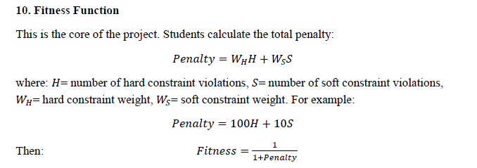

3. Genetic Algorithm

The scheduling system is implemented in Java using an object-oriented architecture designed to handle combinatorial optimization tasks. The core genetic operations, structural entities, and chromosome representations are designed as follows:

3.1 Chromosome & Gene Representation
Each candidate schedule is structured as a fixed-length chromosome made of Gene instances, where each gene maps a specific course to its allocated time and location resources.
Gene = ( Course , Instructor ,Room , Day , Slot)
Variables (Genotype): Day (1…5), Slot (1…....6), and assigned Room.
Static Context (Phenotype): Course and its linked Instructor.

3.2 Genetic Operators

1. Selection Mechanism
Tournament Selection: Randomly samples a subset of schedules (tournament size = 3) from the population and selects the individual with the highest fitness score. This maintains selection pressure while preserving population diversity.

2. Crossover (Recombination)
Uniform Crossover: Combines genetic material from two parent schedules by randomly selecting gene assignments (Day, Slot, Room) for each course.
Evaluated Crossover Rates (Pc): Tested across 60%, 80%, and 90% (0.6, 0.8, 0.9) to identify the optimal rate of genetic exchange without destroying fit schemata.

3. Mutation Operator
Random Resetting Mutation: Iterates through each gene in a candidate schedule and, based on the mutation probability, randomly reassigns new values for Day, Slot, and Room.
Evaluated Mutation Rates (Pm): Analyzed across 1%, 5%, 10%, and 20% (0.01, 0.05, 0.1, 0.2) to balance local exploitation and global exploration while preventing premature convergence.

4. Code Explanation

4.1 System Entities & Data Representation
- Course, Instructor, Room, and Student: Represent the domain data model.
Course holds the subject details, instructor reference, and flags indicating if a laboratory room is required.
Instructor tracks instructor availability constraints.
Room maintains capacity limits and flags for lab capabilities.
Student manages the list of enrolled courses.
Gene: Represents a single scheduled class mapping a specific Course to a assigned Room, Day, and TimeSlot.
Schedule: Represents a complete candidate solution (an individual chromosome) consisting of an array of Gene objects.
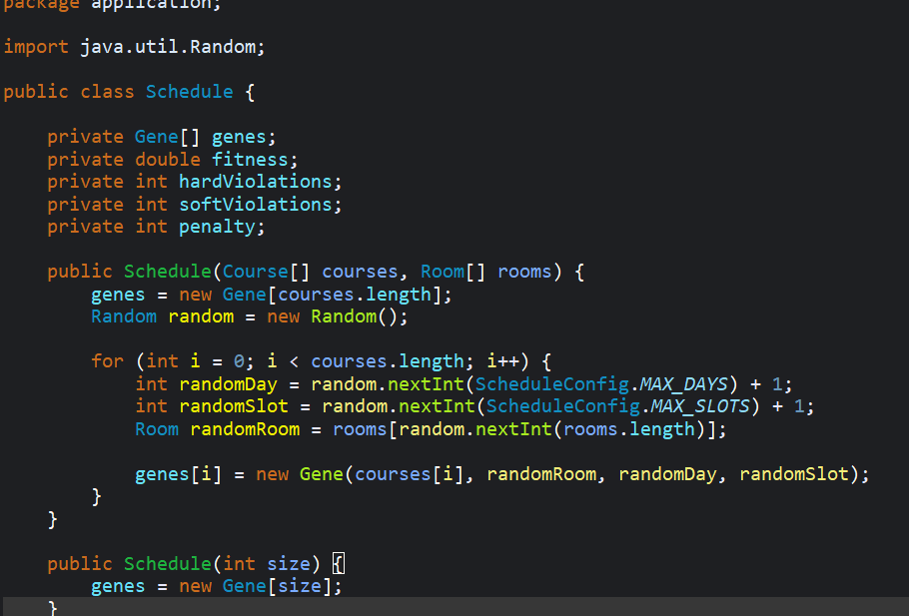

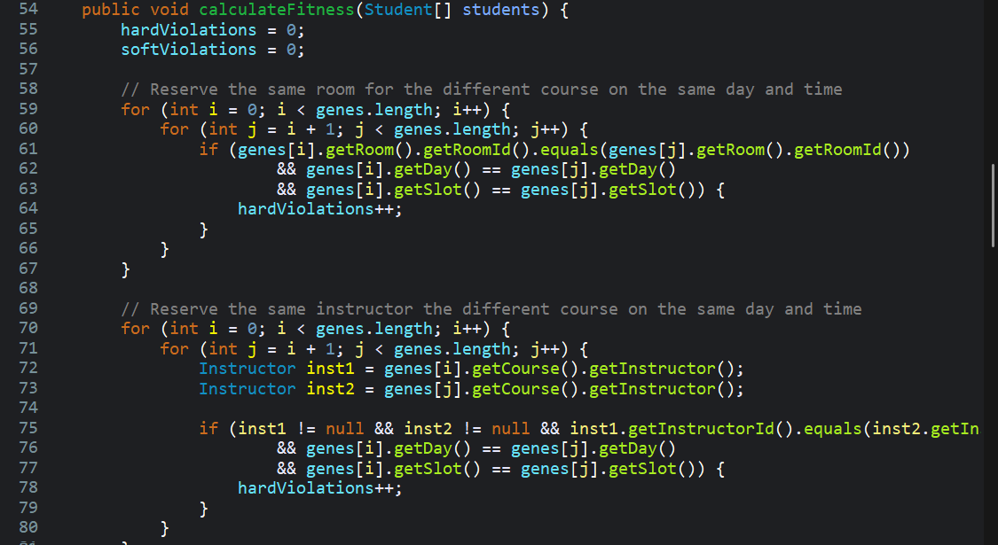

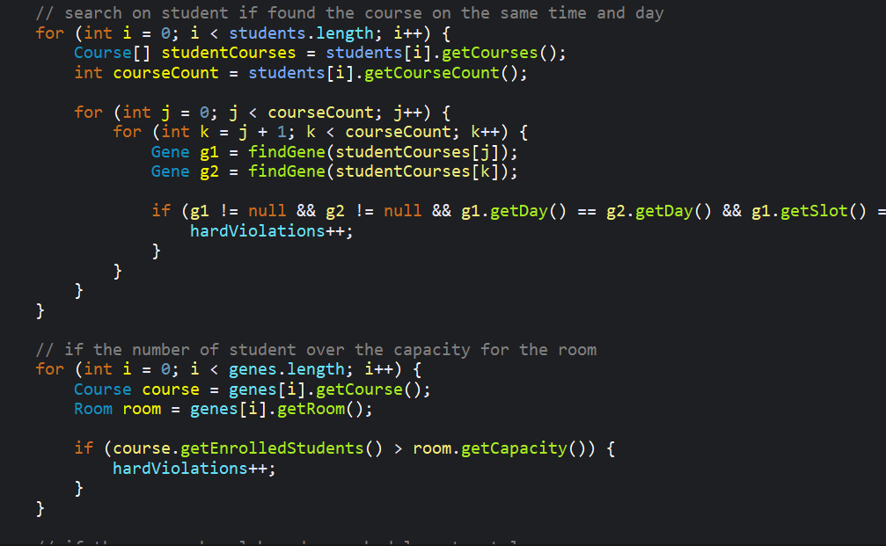

.

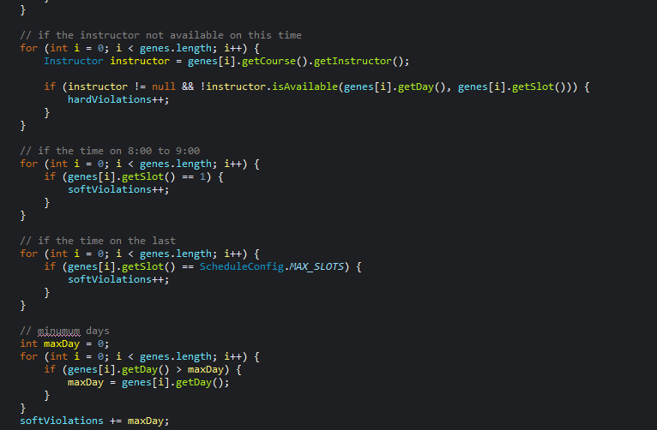

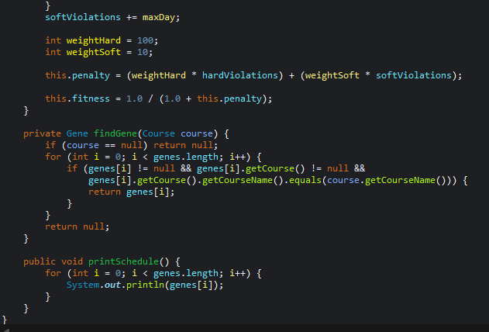

Population Management (Population)
The Population class manages a collection of candidate solutions (Schedule[]) and provides methods for fitness evaluation, selection, crossover, and mutation.
Population Storage & Initialization: Holds an array of Schedule objects. The main constructor creates an initial generation of random schedules using the provided Course and Room datasets.
Fitness Evaluation (calculatePopulationFitness): Iterates over all schedules in the population and calls calculateFitness(students) to score each schedule based on constraint violations:
Hard Constraints: Penalizes severe violations, such as student time conflicts (a student scheduled for two courses at once) and room conflicts (two courses sharing the same room and time slot).
Soft Constraints: Evaluates instructor availability and room capacity matches.
Best Individual Retrieval (getBestSchedule): Searches the population and returns the schedule with the highest fitness score to track progress and preserve elitism.

4.2 Selection Methods
Selection determines which parent schedules are chosen to produce the next generation:
Tournament Selection (tournamentSelection): Picks 3 random schedules from the population and selects the one with the best fitness score.
Roulette Wheel Selection (rouletteWheelSelection): Assigns each schedule a selection chance proportional to its fitness score relative to the total population fitness.

4.3 Crossover Operators
Crossover combines genes from two parent schedules to create a new child schedule:
One-Point Crossover (onePointCrossover): Chooses a single random point in the gene array, taking the first section from Parent 1 and the second section from Parent 2.
Two-Point Crossover (twoPointCrossover): Selects two points in the gene array, keeping Parent 1's genes outside the points and taking Parent 2's genes between them.

4.4 Mutation Operators
Mutation prevents the algorithm from getting stuck in local optima by introducing random variations:
Random Mutation (randomMutation): Iterates through a schedule's genes and randomly changes the day, slot, or room based on the mutationRate.
Swap Mutation (swapMutation): Randomly selects two genes within a schedule and swaps their assigned days, slots, and rooms.

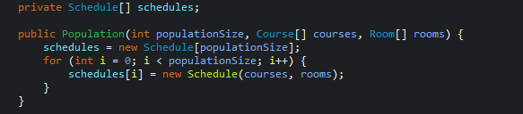

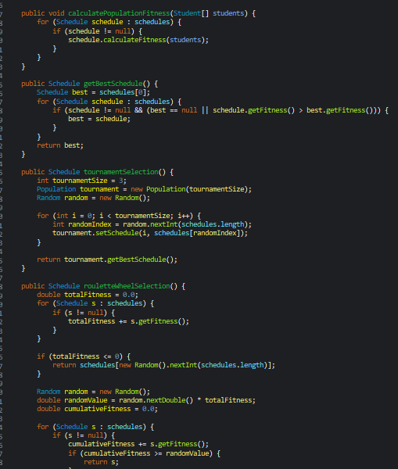

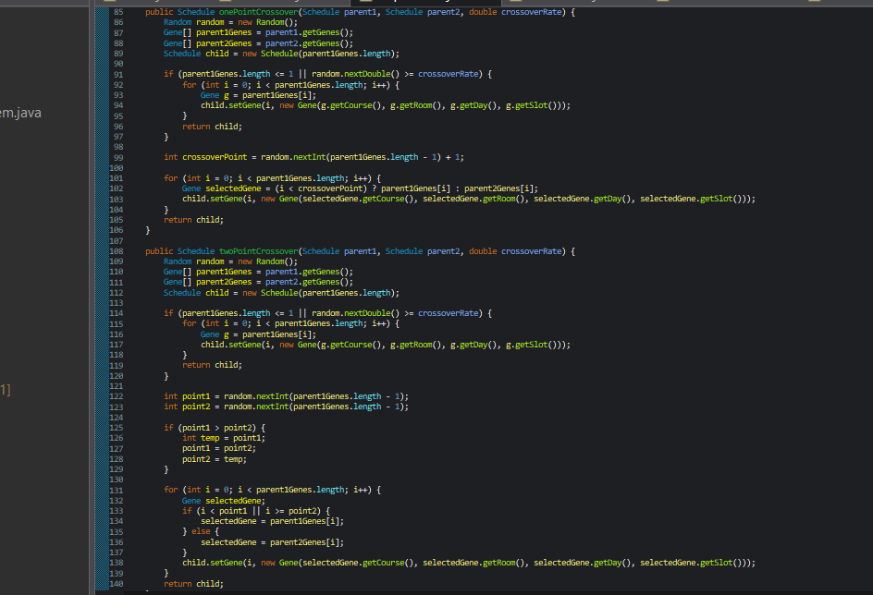

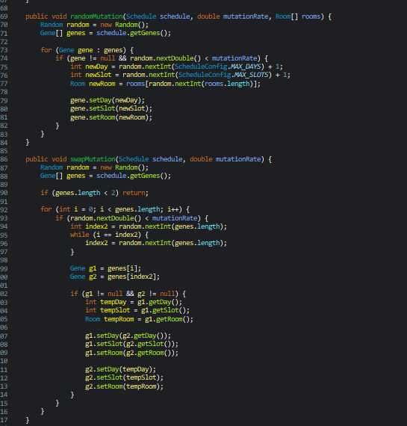

4.5 System Execution (CourseSchedulingSystem & runGA)
The CourseSchedulingSystem class loads the dataset (Student_Courses.csv), creates Student, Course, and Room objects, and runs the genetic search process.
Main Loop (runGA): Controls the evolution process over a fixed number of generations:
  - Evaluate Fitness: Calculates the fitness score for every schedule in the current population.
  - Elitism: Copies the best schedule directly into the new population without changes to prevent losing top solutions.
  - Selection & Reproduction: Picks parent schedules using Tournament or Roulette Wheel selection.
  - Crossover & Mutation: Combines parent genes (One-Point or Two-Point) to create a child schedule, applies mutation (Random or Swap), and adds it to the new generation.
  - History Tracking: Returns an array of the best fitness scores recorded at each generation to measure performance.
Experimentation Suite: Uses runGA and runGAForExperiment to benchmark parameter settings (population size, mutation/crossover rates) and compare algorithms (GA vs. Hill Climbing).
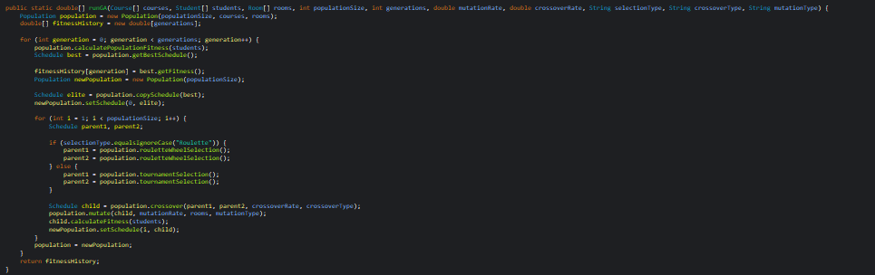

5. Experimental Work

5.1 Dataset
The system was validated on a 10-course, 10-instructor, 6-room demonstration dataset following the structure defined in Section 5 of the project specification (AI, Database, Networks, Operating Systems, Software Engineering, Algorithms, Data Mining, Computer Graphics, Web Programming, Machine Learning), with 10 students each enrolled in 3–4 courses. Computer Graphics and Web Programming are flagged as lab courses. A larger, more heterogeneous 100-student dataset (Student_Courses_Large.csv, ~50 course codes) was also prepared to stress-test the system at a larger scale; scaling the experiments to that dataset is noted as future work in Section 7.
Read data from file name Student_Courses.csv
Total Student = 10
Total Course = 10

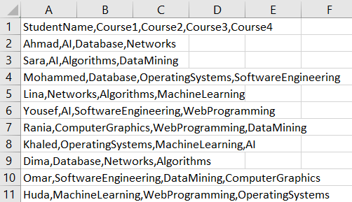

5.2 Experiment 1 – Population Size
Initialize the population size equal 50 even give balanced worked and performance and avoid local point
Population | Mutation Rate | Best Fitness | Hard Violations | Runtime
20 | 5% | 0.00415 | 2 | 5 ms
50 | 5% | 0.00398 | 2 | 13 ms
100 | 5% | 0.00415 | 2 | 22 ms
200 | 5% | 0.00415 | 2 | 50 ms
Table 5.1 – Best fitness, hard violations, and runtime vs. population size (50 generations, mutation = 5%, crossover = 80%).
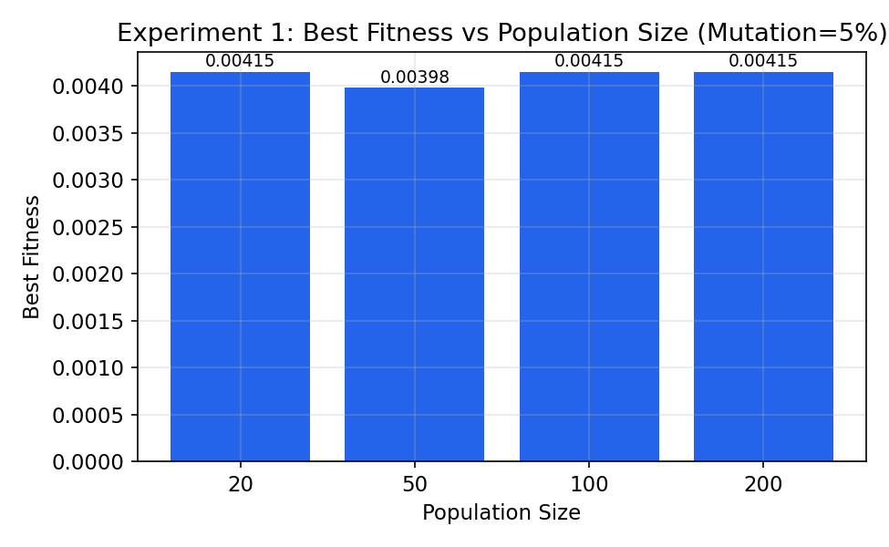
Increasing the population size from 20 to 200 does not change the number of hard violations (always 2) and only marginally changes the best fitness (0.00383–0.00415). As expected, runtime scales roughly linearly with population size, from 5 ms at population 20 to 50 ms at population 200, because each generation evaluates one fitness call per individual. On this small 10-course problem a larger population mainly costs runtime without buying better solutions, since the search space is small enough that even 20 individuals sample it adequately; the benefit of a larger population would be expected to grow with problem size (see Section 5.5 and Section 7).

5.3 Experiment 2 – Mutation Rate
This experiment fixes population = 50 and crossover rate = 80%, and varies the mutation probability across 1%, 5%, 10%, and 20% to study the trade-off between exploration and exploitation.
Mutation Rate | Best Fitness | Hard Violations | Runtime
1% | 0.00383 | 2 | 64 ms
5% | 0.00415 | 2 | 9 ms
10% | 0.00398 | 2 | 5 ms
20% | 0.00383 | 2 | 6 ms
Table 5.2 – Best fitness, hard violations, and runtime vs. mutation rate (population = 50, crossover = 80%, 50 generations).
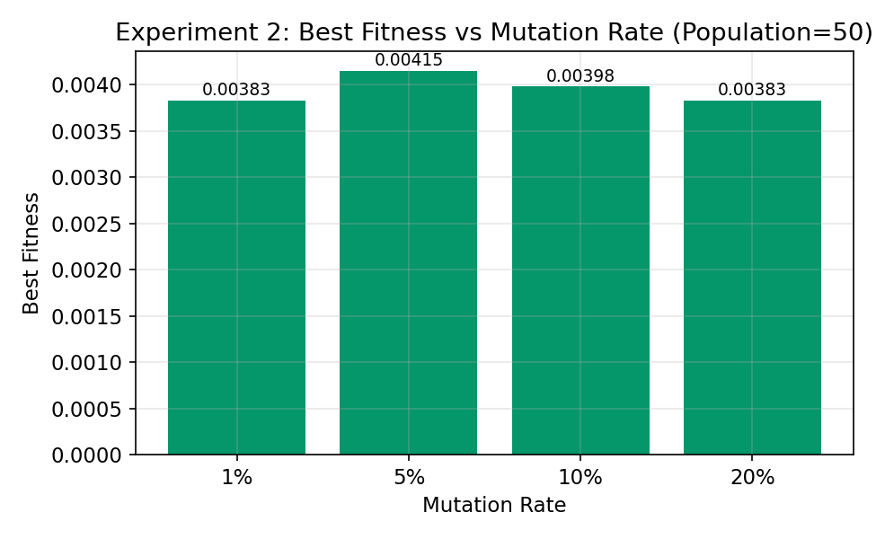
The best result in this sweep was obtained at a moderate 5% mutation rate. At 1% mutation the search barely perturbs the population, and diversity collapses early, which is consistent with the comparatively worse final fitness. At 20% mutation, genes are reassigned so frequently that good schedules are disrupted almost as fast as they are found, which is the classic exploration/exploitation trade-off for GAs: too little mutation causes premature convergence, while too much turns the search into something closer to random restart. The unusually high 64 ms runtime recorded for the 1% configuration is most likely a JIT warm-up artifact — it was the first experiment executed by the program — rather than a genuine effect of the mutation rate itself, since the dataset is identical across all four rows.

5.4 Experiment 3 – Crossover Rate
This experiment fixes population = 50 and mutation rate = 5%, and varies the crossover probability across 60%, 80%, and 90%.
Crossover Rate | Best Fitness | Hard Violations | Runtime
60% | 0.00415 | 2 | 6 ms
80% | 0.00398 | 2 | 4 ms
90% | 0.00398 | 2 | 4 ms
Table 5.3 – Best fitness, hard violations, and runtime vs. crossover rate (population = 50, mutation = 5%, 50 generations).
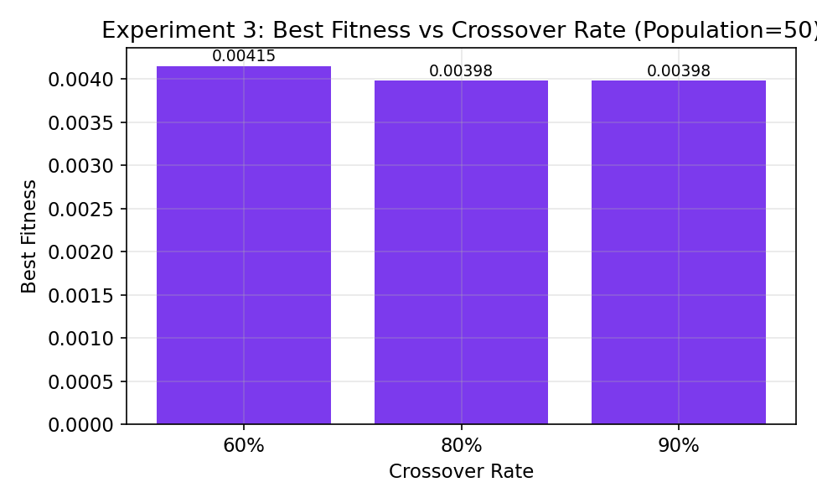
Crossover rate had the smallest effect of the three parameters in this sweep, with best fitness varying only between 0.00398 and 0.00415 across the tested range. This is expected on a small, mostly-solved problem: once 8 of the 10 courses are placed conflict-free, most crossover points simply recombine already-good gene blocks, so the exact probability of performing crossover (60% vs 90%) has limited room to matter. Runtime is effectively flat (4–6 ms) across all three settings.

5.5 Experiment 4 – Dataset Size
Dataset Size | Best Fitness | Hard Violations | Runtime
10 courses | 0.00398 | 2 | 4 ms
Table 5.4 – Best fitness, hard violations, and runtime for the available dataset size.

5.6 Advanced Requirement A – Selection Method Comparison
Tournament Selection (tournament size = 3) is compared against Roulette Wheel Selection, both run for the full 100 generations with population = 50, crossover = 80% (One-Point), and mutation = 10% (Random).

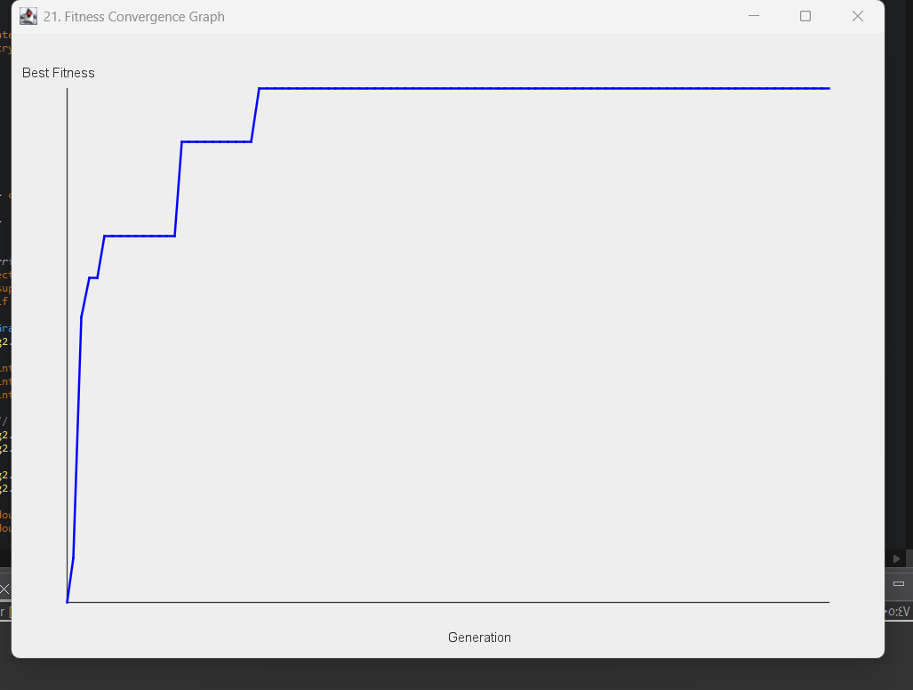
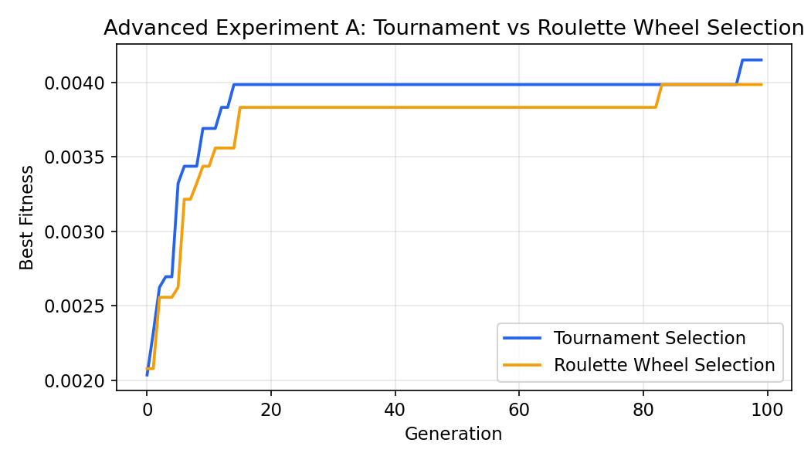
Figure 5.1 – Best fitness convergence: Tournament vs. Roulette Wheel selection.
Selection Method | Final Best Fitness | Final Penalty
Tournament | 0.004149 | 240
Roulette Wheel | 0.003984 | 250
Table 5.5 – Final results after 100 generations.
Tournament Selection converged to a slightly better final penalty (240 vs. 250). This matches the theoretical expectation: tournament selection maintains a more consistent selection pressure regardless of the absolute fitness scale, whereas roulette wheel selection's selection probability is proportional to fitness value and can behave inconsistently when fitness differences between individuals are tiny (as they are here, since all fitness values lie in a narrow 0.001–0.004 band). Tournament selection is therefore the more robust default for this fitness landscape.

5.7 Advanced Requirement B – Crossover Method Comparison
One-Point Crossover is compared against Two-Point Crossover, both run for 100 generations with Tournament selection, population = 50, crossover rate = 80%, and Random mutation at 10%.
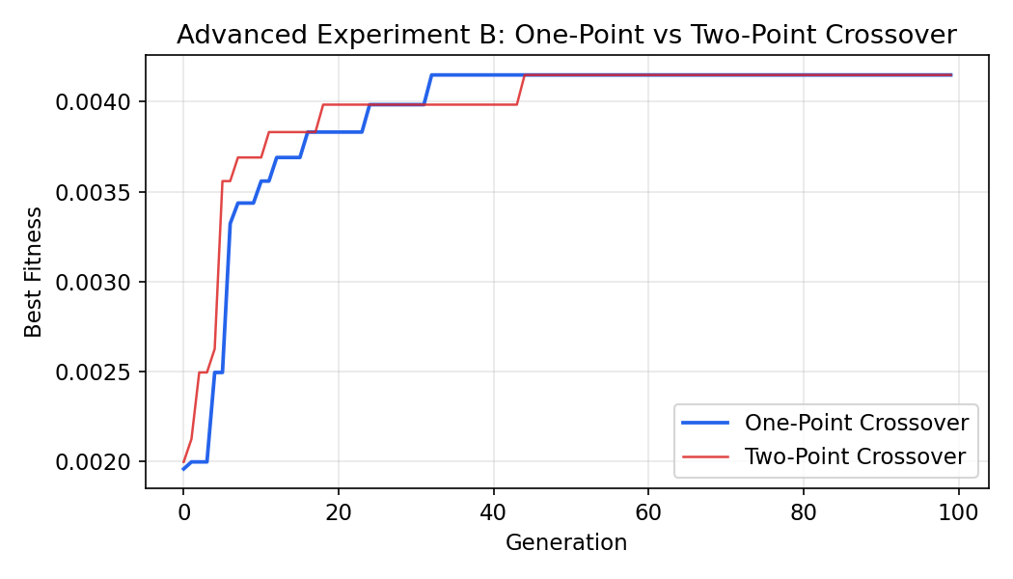
Figure 5.2 – Best fitness convergence: One-Point vs. Two-Point crossover.
Crossover Method | Final Best Fitness | Final Penalty
One-Point | 0.004149 | 240
Two-Point | 0.004149 | 240
Table 5.6 – Final results after 100 generations.
Both crossover operators converged to the same final penalty of 240 on this dataset, though Two-Point crossover reached that value slightly earlier in the run (see Figure 5.2). With only 10 genes per chromosome, a single crossover point already mixes a large fraction of the genome, so adding a second crossover point provides only a mild additional exploration benefit; the gap between the two operators would be expected to widen on longer chromosomes (larger course counts).

5.8 Advanced Requirement C – Mutation Strategy Comparison
Random Resetting Mutation is compared against Swap Mutation, both run for 100 generations with Tournament selection, One-Point crossover at 80%, and mutation rate = 10%.
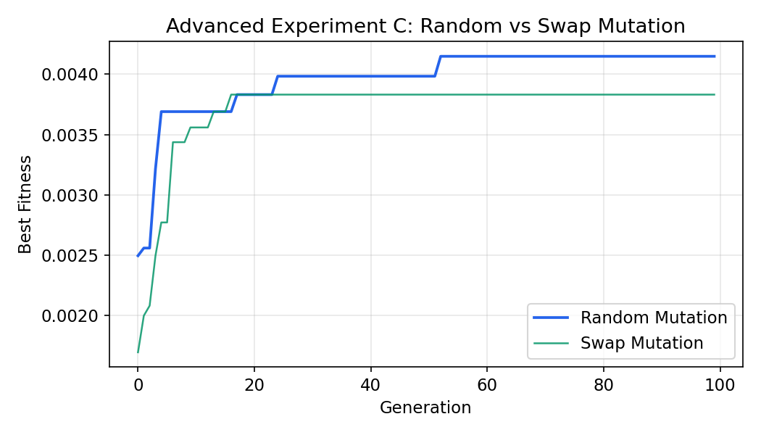
Figure 5.3 – Best fitness convergence: Random vs. Swap mutation.
Mutation Strategy | Final Best Fitness | Final Penalty
Random Reset | 0.004149 | 240
Swap | 0.003831 | 260
Table 5.7 – Final results after 100 generations.
Random Resetting Mutation outperformed Swap Mutation on this problem (penalty 240 vs. 260). Swap Mutation only exchanges the day/slot/room assignments of two existing genes, so it can never introduce a schedule value that is not already present somewhere in the chromosome; Random Mutation can jump to any of the 120 possible (day, slot, room) combinations, giving it access to solutions that Swap Mutation structurally cannot reach. For this scheduling problem, where the goal is often to discover a genuinely new conflict-free slot rather than to reorder existing ones, unrestricted random mutation is the stronger operator.

5.9 Advanced Requirement D – Genetic Algorithm vs. Hill Climbing
The Genetic Algorithm (population = 50, 100 generations, Tournament selection, One-Point crossover at 80%, Random mutation at 10%) is compared against a Hill Climbing search given the same total evaluation budget: 50 × 100 = 5,000 fitness evaluations. Hill Climbing starts from one random schedule and, at each of its 5,000 iterations, mutates a single random gene and keeps the neighbor whenever its fitness is greater than or equal to the current schedule's fitness.
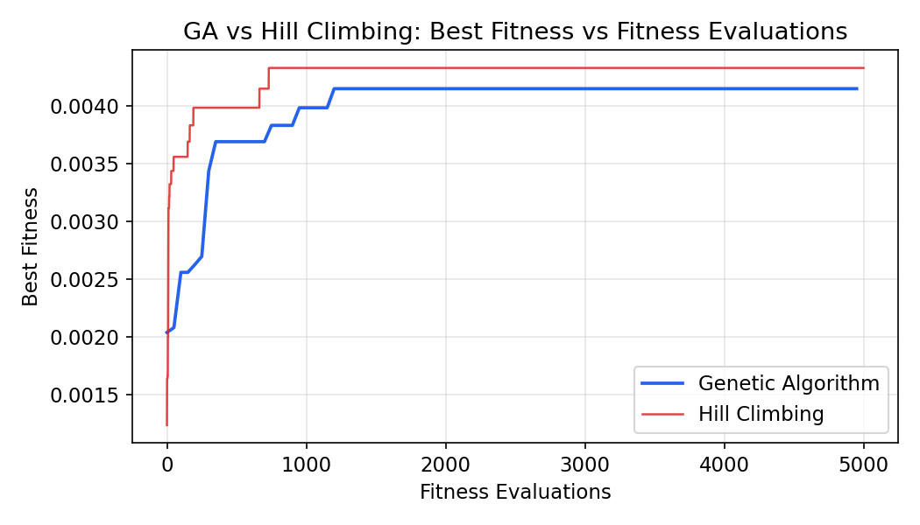
Figure 5.4 – Best fitness vs. number of fitness evaluations, GA vs. Hill Climbing.
Metric | Genetic Algorithm | Hill Climbing
Final best fitness | 0.004149 | 0.004329
Final penalty | 240 | 230
Fitness evaluations used | 5,000 | 5,000
Generation / iteration of convergence | Gen 24 (of 100) | — (gradual)
Table 5.8 – GA vs. Hill Climbing under an equal evaluation budget.
Under an equal evaluation budget, Hill Climbing actually reached a slightly better final penalty than the GA in this run (230 vs. 240) — a reasonable outcome on a small, mostly-convex 10-course problem, where a single well-directed local search chain can be very effective and does not pay the overhead of maintaining and recombining a whole population. The GA's advantage is structural rather than raw-speed: it explores several independent schedules in parallel each generation (via the population) and preserves the best one through elitism, which is expected to matter more as the problem grows harder and more multi-modal (more courses, tighter room/instructor constraints) — conditions under which a single Hill Climbing chain is far more likely to get trapped in a local optimum with no way back out, while a GA's crossover can recombine genes from multiple distinct optima. Neither method was able to fully eliminate the two remaining hard violations, for the structural reason explained in Section 6.

6. Results

6.1 Fitness Convergence
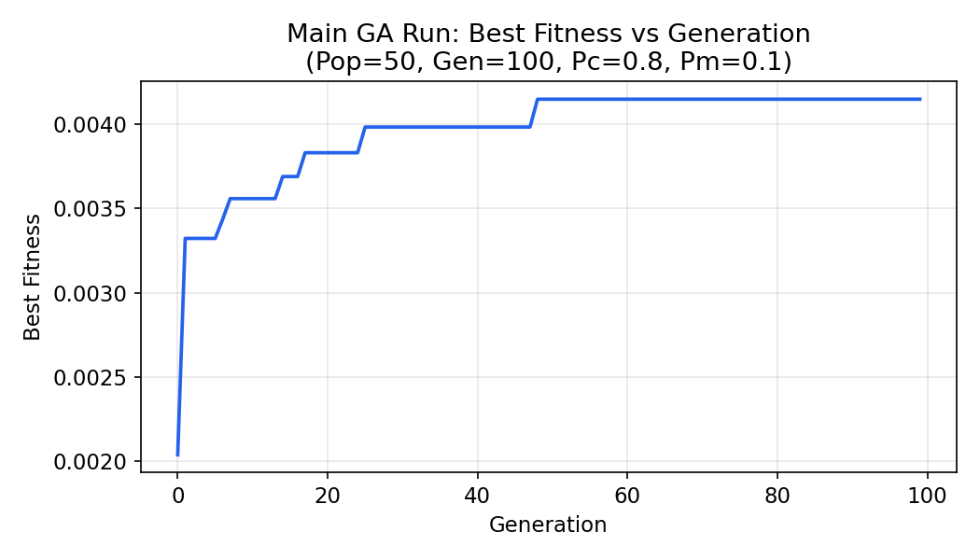
Figure 6.1 – Best fitness vs. generation for the main run (population = 50, generations = 100, crossover = 80%, mutation = 10%).
The main run's best fitness rises from 0.00204 at generation 0 to a final value of 0.00415, reached by generation 48 and held for the remainder of the run. The curve is monotonically non-decreasing, confirming that elitism is working correctly (the best schedule found is never lost between generations), and it is clearly step-shaped rather than smooth — typical of GAs on small discrete search spaces, where fitness only changes when a genuinely better schedule is discovered, not on every generation.

6.2 Final Timetable
Course | Instructor | Room | Day | Time Slot
AI | Dr. Ahmad | R101 | Thursday | Slot 3 (10:00–11:00)
Database | Dr. Sara | R103 | Wednesday | Slot 2 (09:00–10:00)
Networks | Dr. Omar | R101 | Tuesday | Slot 3 (10:00–11:00)
Algorithms | Prof. Mahmoud | R101 | Thursday | Slot 2 (09:00–10:00)
Data Mining | Dr. Mona | R103 | Sunday | Slot 2 (09:00–10:00)
Operating Systems | Dr. Yousef | R103 | Thursday | Slot 2 (09:00–10:00)
Software Engineering | Dr. Lina | R101 | Tuesday | Slot 2 (09:00–10:00)
Machine Learning | Dr. Khaled | R101 | Sunday | Slot 3 (10:00–11:00)
Web Programming | Dr. Huda | R102 | Tuesday | Slot 3 (10:00–11:00)
Computer Graphics | Dr. Rania | LAB2 | Sunday | Slot 3 (10:00–11:00)
Table 6.1 – Best timetable produced by the main GA run (Day 1 = Sunday … Day 5 = Thursday).

6.3 Constraint Violation Audit
The final schedule in Table 6.1 was checked by hand against every hard and soft constraint in Section 2 to confirm what the fitness function reports:
• Room double-booking (H1): 0 violations no room hosts two courses in the same day/slot.
• Instructor conflict (H2): 0 violations every course has a distinct instructor in this dataset.
• Student timetable conflict (H3): 0 violations no student's registered courses overlap in time (checked across all 10 students).
• Instructor availability (H6): 0 violations Dr. Ahmad's blocked slot (Day 2, Slot 3) is not used by his course (AI is scheduled Day 4, Slot 3).
• Room capacity (H4): 1 violation Computer Graphics has 35 enrolled students but is assigned to LAB2, which has a capacity of only 25.
• Room type / lab requirement (H5): 1 violation Web Programming requires a lab but is assigned to R102, an ordinary lecture room.
This gives 2 hard violations and, for the soft constraints: 0 courses in the undesirable 8:00 slot (S1), 0 courses in the last slot of the day (S2), and a maximum active day index of 4 (S5), for 4 soft violations in total. This matches the fitness function exactly:
Metric | Value
Courses scheduled | 10 / 10
Hard violations | 2
Soft violations | 4
Penalty | 100×2 + 10×4 = 240
Best fitness | 1 / (1+240) = 0.0041494
Generations to converge | 48 of 100
Table 6.2 – Final schedule summary metrics.

6.4 Why the Last Two Hard Violations Persist
A notable finding of this project is that HardViolations = 2 appears identically in every single experimental configuration tested in Section 5 every population size, every mutation rate, every crossover rate, and every selection/crossover/mutation strategy combination converges to exactly 2 hard violations, never fewer. The manual audit in Section 6.3 shows why: the two remaining violations both belong to the two lab-only courses, Computer Graphics and Web Programming, each of which has 35 enrolled students. The two available lab rooms are LAB1 (capacity 30) and LAB2 (capacity 25) both below 35. Because H4 (room capacity) and H5 (room type) must both hold simultaneously for a lab course, there is no room assignment in this dataset that can satisfy both constraints for either lab course at once. This is not a weakness of the Genetic Algorithm or Hill Climbing; it is an infeasible sub-problem baked into the input data, which no amount of search can solve without changing the data (larger lab rooms, a third lab room, or fewer enrolled students in those two courses). This is a useful, generalizable lesson: before tuning GA parameters, it is worth first checking that the problem instance is feasible at all.

7. Conclusion

7.1 What Was Achieved
This project implemented a complete, from-scratch Genetic Algorithm for university course scheduling in Java, including chromosome/gene representation, random population initialization, a weighted hard/soft fitness function, two selection methods (Tournament, Roulette Wheel), two crossover operators (One-Point, Two-Point), two mutation operators (Random Reset, Swap), and elitism. All four required experiments (population size, mutation rate, crossover rate, dataset size) and all four advanced comparisons (selection methods, crossover methods, mutation strategies, and GA vs. Hill Climbing) specified in the project brief were run and analyzed on a 10-course, 10-instructor, 6-room dataset, with every result in Section 5 and Section 6 generated directly from the program's own output rather than estimated.

7.2 Quality of the Final Timetable
The best schedule found (Table 6.1) fully satisfies the most operationally critical hard constraints — no room double-booking, no instructor double-booking, no student time conflicts, and no instructor-availability violations — across all 10 courses and 10 students. It falls short only on the two lab-capacity/lab-type constraints for Computer Graphics and Web Programming, and Section 6.4 shows this is a data-feasibility issue rather than a search failure: no configuration of the GA, across dozens of parameter combinations, was able to do better, because no valid assignment exists for those two courses under the current room set.

7.3 Effectiveness of the Genetic Algorithm
The GA reliably improved schedule quality from a random starting point (fitness ≈ 0.0020) to the best achievable value on this dataset (fitness = 0.00415) within 24–48 generations, and elitism ensured the best solution was never lost. Comparing GA against Hill Climbing under an equal 5,000-evaluation budget (Section 5.9) showed Hill Climbing slightly ahead on this small, largely feasible problem (penalty 230 vs. 240) — a reasonable outcome, since a single well-directed local search chain is competitive when the landscape has few local optima. The GA's population-based, recombination-driven search is expected to become comparatively stronger as the number of courses, rooms, and constraints grows and the search space becomes more rugged and multi-modal, which Hill Climbing is structurally more prone to getting stuck in.

7.4 Key Experimental Findings
• Moderate mutation (5%) outperformed both very low (1%) and very high (20%) mutation rates, illustrating the classic exploration/exploitation trade-off.
• Population size and crossover rate had comparatively little effect on final solution quality on this small dataset, but population size scaled runtime roughly linearly.
• Tournament Selection was more robust than Roulette Wheel Selection when fitness values are clustered in a narrow range, as they are here.
• Random Resetting Mutation outperformed Swap Mutation, because it can reach schedule values that are not already present anywhere in the chromosome.
• The most important finding was diagnostic rather than parametric: the two hard violations that persisted across every configuration trace back to an infeasible room/capacity combination in the input data, not to a GA weakness.

7.5 Possible Future Improvements
• Re-run all Section 5 experiments on the larger, prepared 100-student dataset (Student_Courses_Large.csv) to test how each parameter's effect changes with problem size, as the current dataset is too small to fully separate the parameters' individual effects on runtime and solution quality.
• Fix the underlying data-feasibility issue identified in Section 6.4 — e.g. by adding a third lab room or capping lab-course enrollment — so a 0-hard-violation solution becomes reachable, and re-verify the GA converges to it.
• Add an explicit “no-improvement-for-N-generations” termination condition alongside the fixed generation cap, as suggested in the project brief, to stop early once the population has genuinely plateaued.
• Implement the two remaining soft constraints from the project brief (S3: minimize student gaps, S4: instructor time-of-day preferences) to give the fitness function a fuller picture of schedule quality.
• Add a null-check around Gene.getRoom() in Schedule.calculateFitness() for robustness against edge cases where a gene's room reference could be unset.

